Tableau – Appspace
Digital Signage Dashboard Integration
Enterprise Solution Document
Document Type | Enterprise Solution / Reference Document
Scope | Tableau Cloud dashboard display on Appspace digital signage
Owner | Data & BI Support Team
Status | Draft for Review
Version | 1.0
Last Updated | 15 July 2026

Table of Contents
1. Executive Summary
2. Purpose & Scope
3. Solution Overview
4. Architecture & Integration Flow
5. Prerequisites
6. Authentication Setup (Tableau Passport)
7. Card Creation & Configuration
8. Configuration Workflow Diagram
9. Roles & Responsibilities
10. Technical Limitations & Considerations
11. Troubleshooting & Common Errors
12. Support & Maintenance
13. References

1. Executive Summary
This document outlines the enterprise integration between Tableau Cloud and the Appspace digital signage platform. The integration enables live Tableau dashboards to be embedded directly into Appspace "Cards" and published to registered signage devices across the organization, giving stakeholders real-time visibility into business intelligence data on shared displays (office screens, operational monitors, and meeting room signage).
The solution supports two delivery modes: a Public Dashboard mode using Tableau Public URLs, and a Private Dashboard mode using a secure, authenticated connection (Tableau Connected App / Direct Trust) via an Appspace Passport. For enterprise use, the Private Dashboard mode is the recommended and supported approach, as it preserves Tableau Cloud governance, permissions, and data security.

2. Purpose & Scope

2.1 Purpose
To provide a single, authoritative reference for configuring, deploying, and supporting Tableau dashboard cards within Appspace, ensuring consistency across teams and reducing setup errors or support escalations.

2.2 In Scope
- Authentication setup between Tableau Cloud and Appspace (Passport / Connected App).
- Creation and configuration of Tableau Cards in the Appspace Library.
- Publishing dashboards to playlist channels and registered devices.
- Known technical limitations and troubleshooting guidance.

2.3 Out of Scope
- Tableau report embedding (only dashboards are currently supported by Appspace).
- Tableau Desktop workbook development and dashboard design best practices.
- Appspace device hardware provisioning and network configuration.

3. Solution Overview
Appspace provides a purpose-built "Tableau Card" content type within its Library. This card embeds a Tableau dashboard using either a public URL or an authenticated private connection, and the resulting card can be scheduled and pushed to any registered Appspace signage device, the same way as any other content item (images, videos, or other data cards).
Because the dashboard is embedded (not recreated), all visual styling, filters, and data refresh behaviour are controlled entirely within Tableau. Appspace only manages display placement, scheduling, and screen rotation.

4. Architecture & Integration Flow
The diagram below illustrates the end-to-end flow: from dashboard authoring in Tableau Cloud, through authentication and card creation in Appspace, to final rendering on a registered signage device.
Figure 1: Tableau – Appspace integration flow

5. Prerequisites
The following must be in place before integration setup begins:
- Appspace version 8.1 or later.
- Tableau Cloud account with a Creator subscription plan (for private dashboards).
- Tableau Site Administrator Creator role, required to configure a Connected App.
- Appspace Account Owner, Publisher, or Author role, required to create or edit cards in the Library.
- A compatible Appspace-registered display device (refer to the Supported Appspace Cards reference for device compatibility).
Note: A Tableau Public account is required only if using the Public Dashboard mode. This is not recommended for enterprise/internal data.

6. Authentication Setup (Tableau Passport)
Private dashboards require a trusted connection between Tableau Cloud and Appspace, configured once per environment via an Appspace "Passport."

6.1 Steps
- Log in to the Appspace console.
- Open the Appspace menu (☰) → Integrations.
- Select the Passports tab → click + ADD.
- Select the Tableau passport type → click Next.
- In Tableau Cloud, navigate to Settings → Connected Apps to generate the required token (Direct Trust).
- Enter the token details into the Appspace passport configuration screen.
- Click Connect to finalize the trust relationship.
Once connected, this Passport can be reused for any number of Private Dashboard cards — it does not need to be recreated per card.

7. Card Creation & Configuration

7.1 Creating the Card
- From the Appspace menu, select + Quick Action → Create Card, or navigate to Library → select a folder → + CREATE → Card.
- Under All Templates, select Data → Tableau.
- Enter a Title (this also becomes the content file name — mandatory field).

7.2 Public Dashboard Mode
- Paste the Tableau Public dashboard URL into the DASHBOARD field and press Enter.
- Validate the preview; invalid or inaccessible URLs return “This is an invalid URL” or “Dashboard not found” errors.

7.3 Private Dashboard Mode (recommended)
- Select the previously configured Tableau Passport, or create a new one via Set up a new passport.
- Search for and select the required dashboard from the SELECT DASHBOARD list.
- Click Select Dashboard to confirm.

7.4 Additional Settings
- Article tab (optional): caption/referral link shown on mobile or collaboration app views.
- Schedule tab (optional): assign to a channel now, or leave unassigned to configure later.
- Settings tab: confirm Name, set Content Category, Tags, Library Location, and optional Auto Delete / expiry date.
- Click SAVE to publish the card to the Library.

8. Configuration Workflow Diagram
The diagram below summarizes the full setup sequence, from prerequisites through to the dashboard going live on a display device.
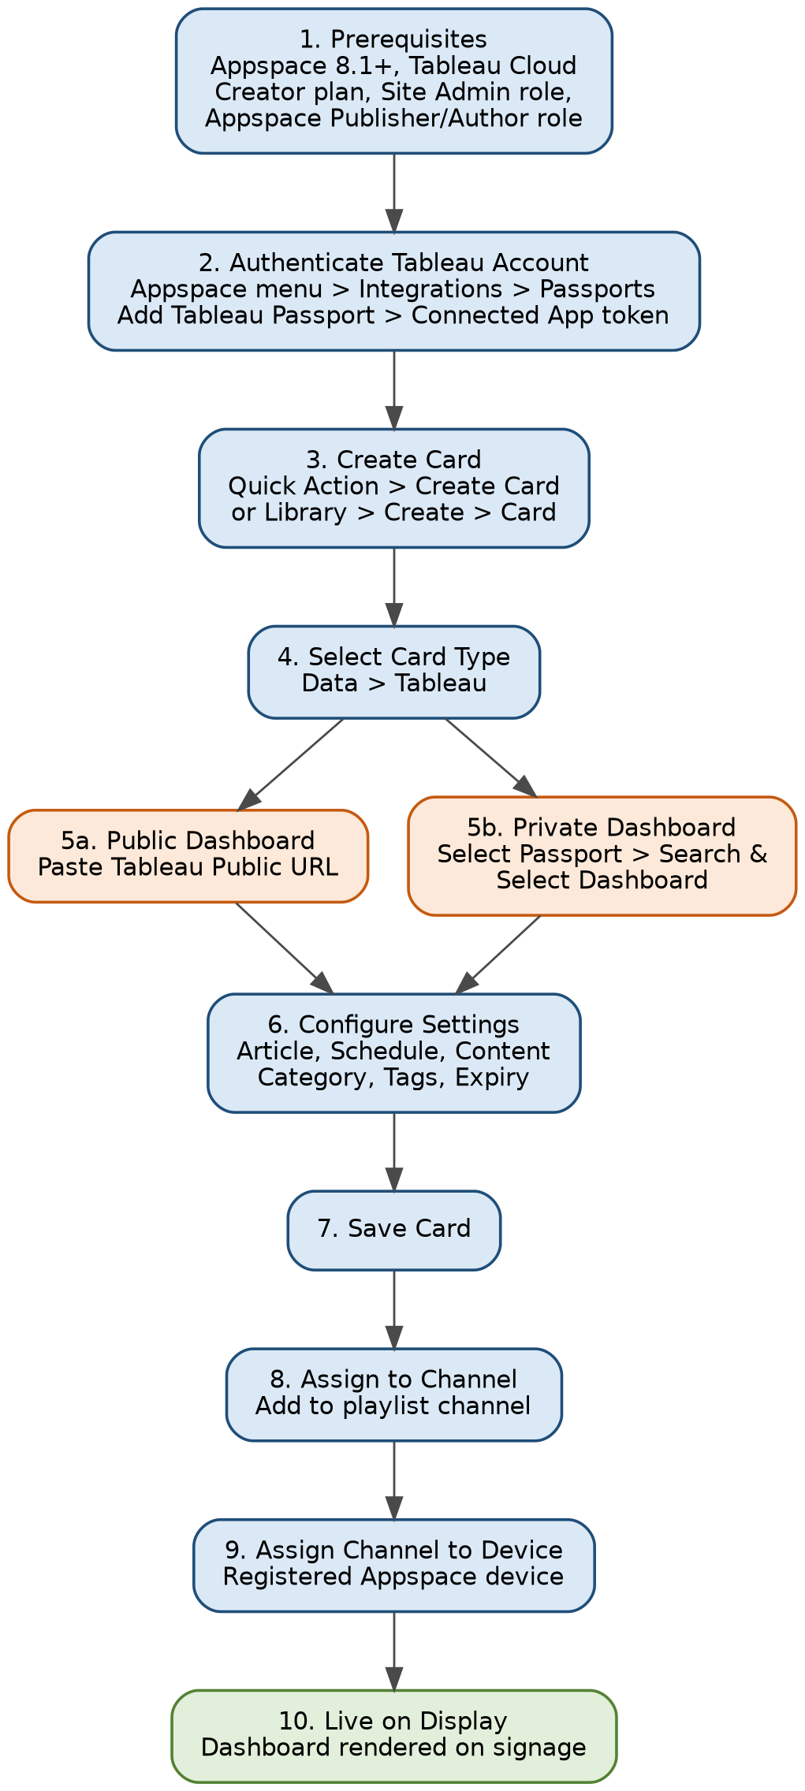
Figure 2: End-to-end configuration workflow

9. Roles & Responsibilities
Role | Responsibility | System
Tableau Site Administrator | Creates and manages Connected App tokens; governs dashboard permissions | Tableau Cloud
Appspace Publisher / Author | Creates, configures, and maintains Tableau Cards in the Library | Appspace
Appspace Account Owner | Manages Passports, channel assignment, and device registration | Appspace
Support Engineer (BI/ETL team) | First-line troubleshooting, monitoring dashboard availability, coordinating fixes | Tableau + Appspace

10. Technical Limitations & Considerations
- Only Tableau dashboards are supported — Tableau reports cannot currently be embedded.
- Tableau dashboards are not fully responsive; design dashboards with the target display canvas/resolution in mind.
- No styling options exist on the Appspace card itself — all visual styling must be done within Tableau.
- Refer to the Tableau Card Release Notes for the current, complete list of technical limitations, as these may change with Appspace version updates.

11. Troubleshooting & Common Errors
Error / Symptom | Likely Cause / Resolution
“This is an invalid URL. Please try again” | The pasted dashboard URL is malformed or not a valid Tableau Public link. Re-copy the URL directly from Tableau Public.
“Dashboard not found” | Dashboard does not exist, the account lacks permission, or the request timed out. Verify access in Tableau Cloud and retry.
Private dashboard not listed in SELECT DASHBOARD | Passport/Connected App token may be expired or scoped incorrectly. Re-authenticate the Passport under Integrations.
Dashboard displays but layout is cut off on device | Dashboard was not designed for the target screen resolution. Adjust the Tableau dashboard size/layout for the display canvas.

12. Support & Maintenance
- Passport tokens should be periodically reviewed and rotated per organizational security policy.
- Any changes to underlying Tableau dashboard permissions should be validated against active Appspace cards to avoid display outages.
- New dashboard cards should follow the same Title/Category/Tag conventions for consistency across the Library.
- Escalation path: Support Engineer (BI/ETL) → Appspace Administrator → Tableau Site Administrator.

13. References
- Appspace Community – Cards: Display Tableau Dashboard: community.appspace.com/cards-134/cards-display-tableau-dashboard-627
- Tableau Help – Configure Connected Apps with Direct Trust (help.tableau.com)
- Appspace Community – Supported Appspace Cards reference article
- Appspace Community – Tableau Card Release Notes

